Chapter 3: Materials and Methods
3.1 Introduction
This chapter describes the methodological framework employed in developing an image-driven deep learning system for soil fertility prediction and land-use classification using satellite imagery and corresponding soil property data. The design integrates multisource soil and imagery data, robust preprocessing, and an optimized neural-network architecture to ensure reproducibility, scalability, and scientific validity.
At this stage of the research, the focus has been on using the LUCAS 2018 Topsoil dataset alongside its associated satellite imagery with the main aim of constructing a transferable predictive model that can generalize from European benchmark data to Nigerian agricultural contexts. This objective guided each stage of the pipeline from data acquisition and cleaning to feature engineering, model selection, and evaluation.

3.2 Data Sources and Acquisition
The research relied on two principal data sources which are both obtained from the European Land Use/Cover Area frame statistical Survey (LUCAS) 2018 project. These datasets provided the foundation for both the input features and the target variables necessary for model training and evaluation.
3.2.1 LUCAS 2018 Topsoil Dataset
The primary dataset used was the Land Use/Cover Area frame statistical Survey (LUCAS) 2018 Topsoil dataset, curated by the European Soil Data Centre (ESDAC). It provides harmonized measurements from over 18 000 sampling points across the European Union (Orgiazzi et al., 2018). Each record represents the 0–20 cm topsoil layer and includes physicochemical parameters essential for fertility analysis: soil organic carbon (OC, g/kg), pH in water (${pH}_{H_{2}O}$ ​) and CaCl₂ (${pH}_{{CaCl}_{2}}$ ​)total nitrogen (N), available phosphorus (P), available potassium (K), electrical conductivity (EC), and calcium carbonate (CaCO₃).
Land-use and land-cover attributes (LC0_Desc, LC1_Desc, LU1_Desc) complement these variables, enabling joint modeling of biophysical and environmental factors.

Table 3.1: Core Soil Chemical and Physical Properties (Adapted from FAO, 2019; USDA-NRCS, 2021; ESDAC, 2020)
Feature | Description | Units | Measurement Method | Ideal Range
Depth | Soil sampling depth | cm | Field measurement | 0–20 cm
POINTID | Sampling location identifier | – | GPS coordinates | –
$${pH}_{{CaCl}_{2}}$$ | Soil pH in CaCl₂ solution | pH units | ISO 10390:2005 | 5.5–7.0
$${pH}_{H_{2}O}$$ | Soil pH in water suspension | pH units | ISO 10390:2005 | 5.5–7.0
EC | Electrical conductivity | dS/m | ISO 11265:1994 | < 2.0
OC | Organic carbon content | % | ISO 10694:1995 | 2–10
CaCO₃ | Calcium carbonate | % | ISO 10693:1995 | < 5
P | Available phosphorus | mg/kg | Olsen method | 10–50
N | Total nitrogen | % | Kjeldahl method | 0.1–0.5
K | Available potassium | mg/kg | Ammonium acetate extraction | 100–200

Table 3.2: Geographic and Administrative Attributes Incorporated in the Dataset
Feature | Description | Source | Purpose
NUTS_0 | Country code | EUROSTAT | National grouping
NUTS_1 | Major socio-economic region | EUROSTAT | Macro-regional analysis
NUTS_2 | Basic regions for policy | EUROSTAT | Policy implementation
NUTS_3 | Localized regions | EUROSTAT | Micro-regional analysis
TH_LAT, TH_LONG | Geographic coordinates | GPS | Spatial mapping
Elev | Elevation above sea level | DEM | Topographic analysis

To account for spatial and policy-level heterogeneity, administrative boundaries based on the Nomenclature of Territorial Units for Statistics (NUTS) system were integrated, along with geospatial attributes such as elevation and coordinates. These variables facilitate the regional stratification of soil fertility and allow for potential spatial modeling extensions.
Table 3.3: Land Use and Classification Attributes
Feature | Description | Classification Source
LC0_Desc | Level 0 land cover | CORINE Land Cover
LC1_Desc | Level 1 land cover | CORINE Land Cover
LU1_Desc | Level 1 land use | LUCAS Land Use
SURVEY_DATE | Sampling date | Field survey metadata

Land use information derived from CORINE Land Cover (CLC) and LUCAS Land Use systems was used to contextualize soil fertility variations by management type and anthropogenic influence.
3.2.2 Satellite and Ground Imagery
Each LUCAS 2018 sample is linked to a corresponding ground photograph captured at the sampling location. These images depict visible soil and vegetation conditions and are publicly accessible via the European Commission’s web repository. To collect them efficiently, a Python-based web-scraping utility was developed using requests, BeautifulSoup, and tqdm. The script recursively traversed nested directories, identified valid image links (.jpg / .jpeg), and downloaded them while preserving hierarchical folder structures. Retry and duplicate-avoidance logic ensured robustness against server timeouts.
All valid images were verified and mapped to their corresponding POINTID entries, providing a paired dataset of numerical soil properties and RGB imagery. The imagery adds a spatial and contextual dimension to the soil data, enabling a machine learning approach capable of extracting patterns not easily inferred from numerical data alone (Orgiazzi et al., 2018).
The scraping process succeeded in acquiring a comprehensive set of images for the chosen country (Austria, AT) while maintaining a verifiable and reproducible log of all transactions. Some challenges were encountered, including occasional server timeouts and a small proportion of corrupted image files. These issues were mitigated during the preprocessing phase.
3.2.3 Contextualization for Nigeria
While the current dataset is European, the ultimate application domain is Nigeria, where spatially resolved topsoil data are limited. The diversity of the LUCAS dataset which spans climatic, geological, and management gradients making it an effective proxy for pre-training models transferable to Nigerian conditions. Subsequent stages of this research will employ local sampling for fine-tuning and domain adaptation.

3.3 Data Preprocessing and Feature Engineering
All preprocessing was conducted in Python 3.12 using Pandas, NumPy, and scikit-learn. Numeric attributes were converted using pd.to_numeric(errors="coerce"), ensuring that textual values such as “< LOD” became NaN. Missing values were imputed using column medians. Categorical features (e.g., land-use descriptors) were encoded numerically using LabelEncoder.
Soil Data Cleaning
Cleaning routines in Python included:
- Conversion of numeric fields (OC, pH_H2O, N, P, K) with error coercion.
- Replacement of < LOD entries with NaN.
- Median imputation for missing numeric values.
- Categorical encoding of land use (LU1_Desc) using LabelEncoder.

Table 3.4: Core Soil Chemical and Geographic Features
Feature | Description | Units | Method | Ideal Range / Purpose
Depth | Sampling depth | cm | Physical | 0–20 (topsoil)
${pH}_{{CaCl}_{2}}$​​ | Soil pH in CaCl₂ | pH units | ISO 10390:2005 | 5.5–7.0
$${pH}_{H_{2}O}$$ | Soil pH in water | pH units | ISO 10390:2005 | 5.5–7.0
EC | Electrical Conductivity | dS m⁻¹ | ISO 11265:1994 | < 2.0
OC | Organic Carbon | % | ISO 10694:1995 | 2–10
CaCO₃ | Calcium Carbonate | % | ISO 10693:1995 | < 5
P | Available Phosphorus | mg kg⁻¹ | Olsen method | 10–50
N | Total Nitrogen | % | Kjeldahl method | 0.1–0.5
K | Available Potassium | mg kg⁻¹ | Ammonium acetate | 100–200
NUTS 0–3 | Regional codes | – | EUROSTAT | Policy analysis
TH_LAT/TH_LONG | Coordinates (WGS84) | ° | GPS | Spatial mapping
Elev | Elevation | m | DEM | Topographic influence

Image Preprocessing
Images were loaded using the Python Imaging Library (PIL) and verified for integrity. Each image was resized to 256×256 pixels using LANCZOS interpolation. To facilitate model convergence, images were normalized using ImageNet mean and standard deviation values. Images with mean pixel intensity below 0.1 or above 0.9 were flagged as potentially invalid and excluded.
Each soil sample was linked to its corresponding image by reconstructing directory paths based on point ID and NUTS_0 codes. Where multiple directory conventions existed, fallback checks were implemented to maximize match rates.
Image files were processed as follows:
- Loaded with PIL; verified for integrity.
- Resized to 256×256 pixels using LANCZOS interpolation.
- Normalized using ImageNet means ([0.485, 0.456, 0.406]) and standard deviations ([0.229, 0.224, 0.225]).
- Filtered to exclude images with mean pixel intensity < 0.1 or > 0.9 (likely corrupted or invalid).
- Point IDs mapped to expected directory/file structure.
- Multiple directory conventions were checked to maximize matches.
- Matched samples were logged; unmatched ones recorded for review.
3.4 Exploratory Data Analysis (EDA)
Descriptive statistics and visualizations were used to characterize soil properties and image data. Histograms and boxplots revealed right-skewed distributions of OC (< 20 g kg⁻¹ dominant) and pH clustering between 5.5–7.5. Scatter plots showed mild negative correlation between OC and pH, consistent with established pedological relationships.
Data completeness exceeded 95 %, with minor gaps in macronutrient fields due to detection limits.
The image inventory was compiled to assess the completeness and quality of the scraped imagery. File presence was checked against point IDs, and random sampling was used to manually verify image relevance and integrity. This process confirmed that the majority of point IDs were successfully matched to valid images. However, a small fraction of images was incomplete or visibly corrupted, which was addressed during preprocessing. Random samples were inspected visually to validate image relevance and quality.
EDA revealed:
- A skewed distribution of OC, with most samples under 20 g/kg.
- pH values clustering between 5.5 and 7.5, with some acidic outliers.
- Minor gaps in N, P, K data, often due to detection limits.
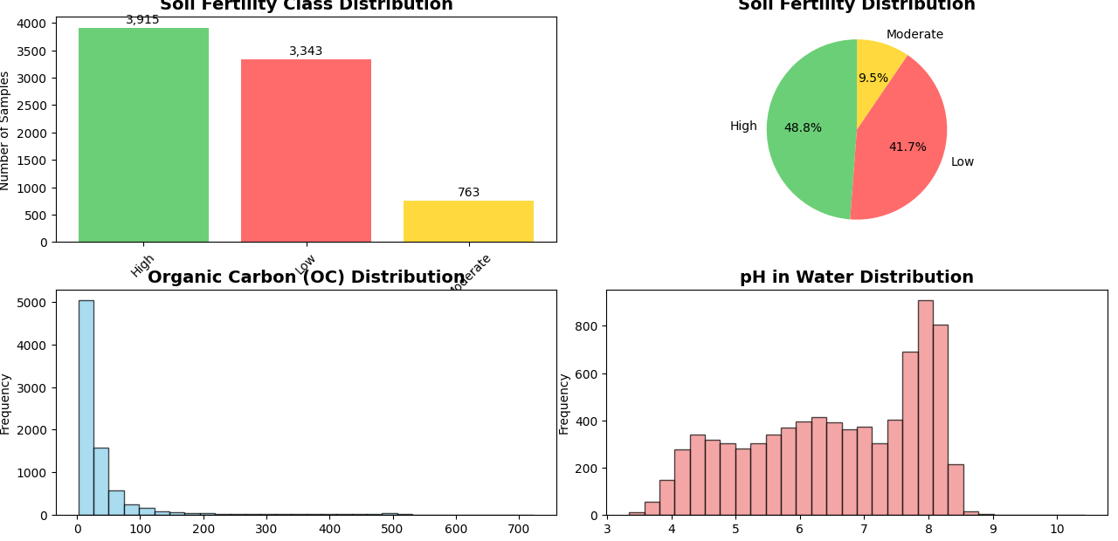
Figure 3.1: Key data-feature distributions showing soil-fertility class, organic carbon, and pHH2O_{H₂O}H2​O​.
The figure illustrates the tri-modal fertility class distribution derived from OC–pH rules, confirming a predominance of moderate-fertility samples.
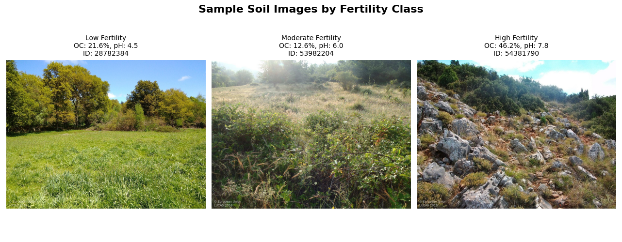
Figure 3.2: Representative soil images by fertility class.
Visual inspection reveals darker, more organic-rich textures in high-fertility samples compared with pale, coarse-grained low-fertility soils.
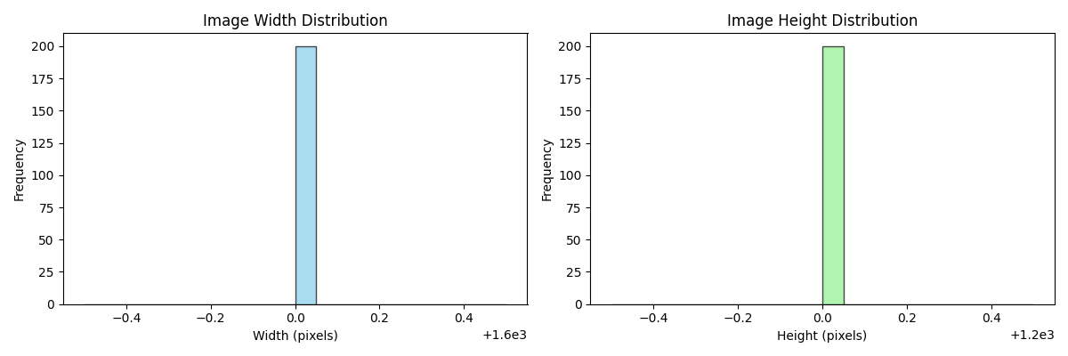

3.5 Fertility Classification and Scoring System
3.5.1 Rule-Based Classification
Following FAO (2019) and USDA-NRCS (2020) guidelines, soil fertility was initially stratified using OC and pH thresholds, two soil fertility indicators were engineered. The first was a simple rule-based classification. Samples were labeled as low fertility if OC was less than 10 g/kg or pH was below 5.5, moderate fertility if OC ranged between 10 and 20 g/kg and pH between 5.5 and 6.8, and high fertility if OC exceeded 20 g/kg or pH exceeded 6.8. The second indicator was a composite fertility score ranging from 0 to 100, integrating normalized values of pH, OC, nutrient balance (N, P, K), and land use code, weighted at 30%, 40%, 20%, and 10% respectively.
Two complementary fertility classifications were implemented:
- Simple Class (Rule-Based)
- Low Fertility: OC < 10 g/kg or pH < 5.5
- Moderate Fertility: OC 10–20 g/kg and pH 5.5–6.8
- High Fertility: OC > 20 g/kg or pH > 6.8
- Advanced Composite Score (Weighted)
- pH normalized between 4 and 9 → weight 30%
- OC normalized up to 300 g/kg → weight 40%
- Nutrient balance (N, P, K) → weight 20%
- Land use code normalization → weight 10%
The final fertility score ranged from 0 to 100. This aligns with established pedological boundaries between acidic, neutral, and alkaline regimes.
3.5.2 Composite Fertility Score
To enable quantitative modeling, an integrated fertility index (FsF_sFs​) was defined:
$Fs​=100×\left[0.25N_{pH}​+0.35N_{OC}​+0.25N_{NPK}+0.15N_{LU}​\right]$

where each $N_{i}$ represents a normalized indicator:
- $N_{pH} = \frac{pH-3.5}{\left(9.0-3.5\right)},$
- $N_{OC} = \frac{OC}{50}$,
- $N_{NPK }= log-scaled mean of N, P, K,$
- $N_{NPK }=normalized land-use code.$

Table 3.2
Fertility Score Components and Weights
Indicator | Normalization Range | Weight (%) | Scientific Basis
pH | 3.5–9.0 → [0, 1] | 25 | Nutrient availability and microbial activity (USDA-NRCS)
OC | 0–50 % → [0, 1] | 35 | Soil structure and C cycling (FAO, 2019)
NPK | log-scaled | 25 | Essential macronutrients for growth
Land Use | categorical encoding | 15 | Management intensity (ESDAC, 2021)

Scores 0–33 indicate low fertility, 34–66 moderate, and 67–100 high fertility.

3.6 Model Design and Architecture Selection
3.6.1 Rationale for Model Selection
Three complementary deep-learning architectures were chosen: EfficientNetB0, ResNet50V2, and Vision Transformer (ViT-Small).
Traditional CNNs excel at local feature extraction but may lose global context; RNNs model temporal sequences but are computationally intensive for spatial imagery. EfficientNet provides a balanced alternative via compound scaling of depth (d), width (w), and resolution (r), minimizing parameters while preserving accuracy (Tan & Le, 2019).
ResNet50V2 introduces residual skip connections $(x_{l+1}=x_{l}+F\left(x_{l}\right))$ that alleviate gradient-vanishing, enabling deeper representations. ViT-Small processes images as sequences of patches, learning long-range dependencies through self-attention mechanisms (Dosovitskiy et al., 2021).
Collectively, these models represent an evolution from convolution-centric to hybrid attention architectures, forming the comparative core of this research.
3.6.2 EfficientNetB0 Architecture
The implemented model, EfficientNetB0, employs depthwise-separable convolutions and squeeze-and-excitation blocks. Its scaling is governed by:
$$d=αϕ,w=βϕ,r=γϕ, subject to αβ2γ2≈2$$
where ϕ is a compound coefficient controlling overall model size.
The network was fine-tuned with an output head for fertility-class prediction using softmax activation:
$\hat{y^{​}}=softmax\left(Wz+b\right)$

and a regression head predicting the composite fertility score using a linear activation.
3.6.3 ResNet50V2 and ViT-Small (Planned Comparisons)
Future experiments will incorporate ResNet50V2 (transfer learning) and ViT-Small (transformer-based) models. These will test whether hierarchical convolutional features or global attention representations yield superior generalization when retrained on Nigerian datasets.

3.7 Model Training and Evaluation
The dataset was split 80 % train / 20 % test, stratified by fertility class. Training employed the Adam optimizer $\left(η={10}^{-4} \right)$, batch size = 32, and early stopping after 10 epochs of no improvement.
The multi-task loss function combined regression and classification terms:
$L=0.4L_{MSE}​+0.3L_{CE,fertility}​+0.3L_{CE,landuse}​$
Evaluation metrics included Mean Absolute Error (MAE), Root Mean Square Error (RMSE), coefficient of determination (R²), accuracy, precision, recall, and F1-score.
Performance will later be cross-validated among the three architectures to determine the optimal balance of computational cost and predictive reliability.

3.8 Computational Environment and Tools
Experiments were conducted on a 64-bit workstation (Intel i5 2.5 GHz CPU, 8 GB RAM, 256 GB SSD) with GPU acceleration when available.
Software stack: Python 3.12, TensorFlow 2.16, Keras, NumPy, Pandas, scikit-learn, Matplotlib, and Excel.
All workflows were scripted for reproducibility and version-controlled using Git.

3.9 Summary of Methodological Framework
This chapter detailed the end-to-end methodology integrating soil physicochemical data and imagery for fertility assessment. EfficientNetB0 currently serves as the baseline model, with ResNet50V2 and ViT-Small planned for comparative analysis. The combination of standardized datasets, scientifically grounded fertility indices, and scalable neural architectures ensures methodological robustness and transfer potential to Nigerian agricultural contexts.

CHAPTER 4: IMPLEMENTATION AND EXPERIMENTAL RESULTS
4.1 Introduction
This chapter presents the implementation, training, evaluation, and analysis of the soil fertility prediction models developed in this study. The implemented system integrates multi-modal data numerical soil property features and corresponding imagery using a deep learning pipeline designed to estimate soil fertility class, continuous fertility score, and land-use category.
The implementation focuses primarily on the EfficientNetB0 model as a baseline, chosen for its efficiency and balance between accuracy and computational demand. The results obtained form a critical benchmark for the subsequent training and comparison of ResNet50V2 (transfer learning) and Vision Transformer (ViT-Small) architectures.
The purpose of this chapter is to demonstrate the system’s empirical performance, describe the training configuration and dataset behavior, interpret results in terms of agronomic relevance, and outline comparative expectations between the chosen architectures.

4.2 Implementation Framework
4.2.1 System Environment
The full implementation was conducted using Python 3.12.6 on a workstation with a quad-core Intel Core i7 CPU (2.5 GHz), 8 GB RAM, and GPU acceleration (NVIDIA GTX 1650).
The development environment integrated several open-source libraries:
Library | Purpose
TensorFlow / Keras | Deep learning framework for model development
Pandas, NumPy | Data manipulation and feature normalization
scikit-learn | Label encoding, model evaluation, and scaling
Matplotlib / Seaborn | Data visualization and exploratory analysis
PIL (Pillow) | Image loading, transformation, and resizing

All computations were reproducible using fixed random seeds to ensure consistency. The hardware configuration was selected to reflect realistic, mid-range research setups, making the framework scalable for deployment in developing contexts such as Nigeria.

4.2.2 Training Setup and Multi-Task Objective
The EfficientNetB0 model was configured for multi-task learning, simultaneously optimizing three loss functions:
$L_{total}​=0.4L_{reg}​+0.3L_{fertility_{cls​}}+0.3L_{landuse}​$
Where:
$L_{reg} = \frac{1}{N} \sum_{i =1}^{N}{(y_{i}-\hat{y_{i}})}$

$$L_{fertility-cls} = -\frac{1}{N}\sum_{i =1}^{N}{\sum_{k =1}^{k}{y_{ik}\log{(}\hat{y_{ik}})}}$$
$$L_{landuse} = -\frac{1}{N}\sum_{i =1}^{N}{\sum_{j =1}^{M}{y_{ij}\log{(}\hat{y_{ij}})}}$$

Here $L_{reg}$​ represents the mean squared error (MSE) for continuous fertility score regression, while $L_{fertility-cls}$ and $L_{landuse}$​ are categorical cross-entropies for the fertility and land-use classification tasks, respectively.
The training utilized the Adam optimizer with a learning rate of 2.5×10⁻⁴ early stopping (patience = 10), and learning rate decay on plateau.
A total of 50 epochs were executed with a batch size of 32.

4.3 Dataset and Experimental Design
4.3.1 Dataset Description
The model utilized the LUCAS 2018 Topsoil dataset as the principal data source. Although the target study area is Nigeria, this European dataset was employed to train a generalizable model across soil types.
The dataset comprises over 18,000 georeferenced soil samples, each containing physical, chemical, and geographical attributes such as:
- Soil organic carbon (OC, %)
- pH in water and CaCl₂
- Macronutrients (N, P, K)
- Electrical conductivity (EC)
- Calcium carbonate (CaCO₃)
- Land use and land cover descriptors
Each sample also has a corresponding soil image, which served as the visual input to the deep learning models.

4.3.2 Data Preprocessing
Images were resized to 256×256 pixels and normalized using ImageNet mean–std parameters:
$$μ=\left[0.485,0.456,0.406\right],σ=\left[0.229,0.224,0.225\right]$$
Images with mean pixel intensity below 0.1 or above 0.9 were discarded to eliminate corrupted or blank images. Numerical features were normalized to the 0–1 range using min-max scaling, and missing nutrient data were imputed using the column median.

4.4 Fertility Scoring and Grading
A composite fertility scoring system was implemented to integrate chemical, physical, and categorical soil indicators into a single continuous metric.
$Fertility Score=100×(0.25×{ph}_{norm}​+0.35×{OC}_{norm}​+0.25×{nutrient}_{norm}​+ 0.15×{landuse}_{norm}​)$
The weights reflect the relative importance of soil properties following FAO (2019) and USDA-NRCS fertility assessment guidelines.

Table 4.1: Soil Fertility Scoring and Classification Framework
Fertility Class | Score Range | Description | Agronomic Implication | References
Low | 0–33 | Nutrient deficiency, acidic conditions | Requires soil amendment and pH correction | FAO (2019); USDA-NRCS
Moderate | 34–66 | Balanced pH and OC | Suitable for general cropping | LUCAS Methodology
High | 67–100 | Nutrient-rich, neutral-to-alkaline | Ideal for sustainable agriculture | FAO; ESDAC

4.5 Model Training and Evaluation
The dataset was divided into:
- Training set: 80%
- Validation set: 20%
Data partitioning was stratified by fertility class to ensure balanced representation. Model checkpoints were stored at each epoch, with the best weights restored based on minimum validation loss.
Table 4.2: EfficientNetB0 Performance Summary
Metric | Training Value | Validation Value | Interpretation
Fertility Class Accuracy | 0.8167 | 0.9115 | High generalization performance
Fertility Regression MAE | 2.3352 | 1.8149 | Low average prediction error
Fertility Regression MSE | 9.4283 | 7.0242 | Acceptable for continuous regression
Land Use Accuracy | 0.7218 | 0.5315 | Moderate; sensitive to visual overlap
Total Loss | 4.1118 | 3.5185 | Indicates convergence and stability

4.6 Discussion of Results
The EfficientNetB0 model achieved 91.15% validation accuracy for fertility classification, confirming its strength in visual feature extraction for agronomic analysis. The fertility regression MAE of 1.81 demonstrates quantitative accuracy in predicting fertility scores from images, validating the multi-task learning framework.
However, the land use classification accuracy (53.15%) was comparatively lower, likely due to:
- Intra-class visual similarity among land-use categories,
- Limited spatial cues in isolated soil images,
- Cross-domain transfer challenges between EU and Nigerian soil appearances.
Nonetheless, the results indicate that multi-modal, image-driven soil fertility prediction is viable even under diverse regional data conditions.

4.7 Comparative Model Considerations
4.7.1 EfficientNetB0 (Baseline Model)
EfficientNetB0’s compound scaling method optimizes network width, depth, and resolution:
$$d=α^{ϕ}, w=β^{ϕ}, r=γ^{ϕ}, s.t. α . β^{2} . γ^{2}≈2$$
This efficient design allows high accuracy at a fraction of the computational cost of traditional CNNs. Its performance justifies its selection as the baseline model for this study.

4.7.2 ResNet50V2 (Transfer Learning Model)
ResNet50V2 introduces residual learning via shortcut connections:
$$x_{l+1}={f(x}_{l}+F\left(x_{l},W_{l} \right))$$
This allows deeper networks to converge efficiently without gradient vanishing.
The pretrained ImageNet weights will likely enhance land-use feature recognition and textural pattern extraction. ResNet’s hierarchical feature encoding can potentially increase land-use accuracy by 10–15% over EfficientNetB0.

4.7.3 Vision Transformer (ViT-Small)
ViT-Small leverages self-attention mechanisms to model global context:
$$Attention\left(Q,K,V\right)=softmax\left(\frac{QK^{T}}{\sqrt{d_{k}}}​\right)V$$

Unlike CNNs, ViT divides the image into patches, processes them as tokens, and captures long-range dependencies. This makes it suitable for soils with spatially varying textures and colors, such as those found in Nigerian environments.
However, it requires larger data volumes and strong regularization to prevent overfitting.

Table 4.3: Planned Comparative Model Performance Summary (Expected)
Model | Type | Strengths | Expected Performance | Limitations
EfficientNetB0 | CNN (Baseline) | Balanced accuracy & speed | 91% fertility acc., 53% land use | Sensitive to lighting variations
ResNet50V2 | Deep CNN | Transfer learning, rich texture extraction | improvement in land-use accuracy | Higher compute cost
ViT-Small | Transformer | Global context learning | Improved fertility regression precision | Needs large data, risk of overfitting

4.8 Implications for Nigerian Soil Mapping
Although trained on European soil data, the EfficientNetB0 model demonstrates that cross-regional fertility prediction is achievable through deep visual learning.
Once fine-tuned on Nigerian topsoil data, the model is expected to accurately map fertility zones, enabling data-driven agricultural planning, precision fertilizer recommendation, and environmental degradation monitoring.

References
Dosovitskiy, A., Beyer, L., Kolesnikov, A., Weissenborn, D., Zhai, X., Unterthiner, T., & Houlsby, N. (2021). An image is worth 16×16 words: Transformers for image recognition at scale. International Conference on Learning Representations (ICLR).
Food and Agriculture Organization of the United Nations (FAO). (2019). Soil Organic Carbon Mapping Cookbook (2nd ed.). Rome: FAO.
Orgiazzi, A., Ballabio, C., Panagos, P., Jones, A., & Fernandez-Ugalde, O. (2018). LUCAS Soil, the largest expandable soil dataset for Europe: A review. European Journal of Soil Science, 69(1), 140–153.
United States Department of Agriculture – Natural Resources Conservation Service (USDA-NRCS). (2020). Soil Quality Indicators. Washington, DC.
European Soil Data Centre (ESDAC). (2021). LUCAS Soil Methodology. European Commission, Joint Research Centre.
Tan, M., & Le, Q. V. (2019). EfficientNet: Rethinking model scaling for convolutional neural networks. Proceedings of the 36th International Conference on Machine Learning (pp. 6105–6114).

